**Project 10: Product Demand Analysis**

**PHASE 2 : INNOVATION**

**410721243039 : JANASTHUTHI M S**

**Design Thinking**

The end users of the model will be the supply chain team, who will use it to make decisions about inventory levels. The model needs to be accurate and easy to use, so that the team can make informed decisions quickly and efficiently.

**Data Collection and Preprocessing**

Dataset: <https://www.kaggle.com/datasets/chakradharmattapalli/product-demand-prediction-with-machine-learning>

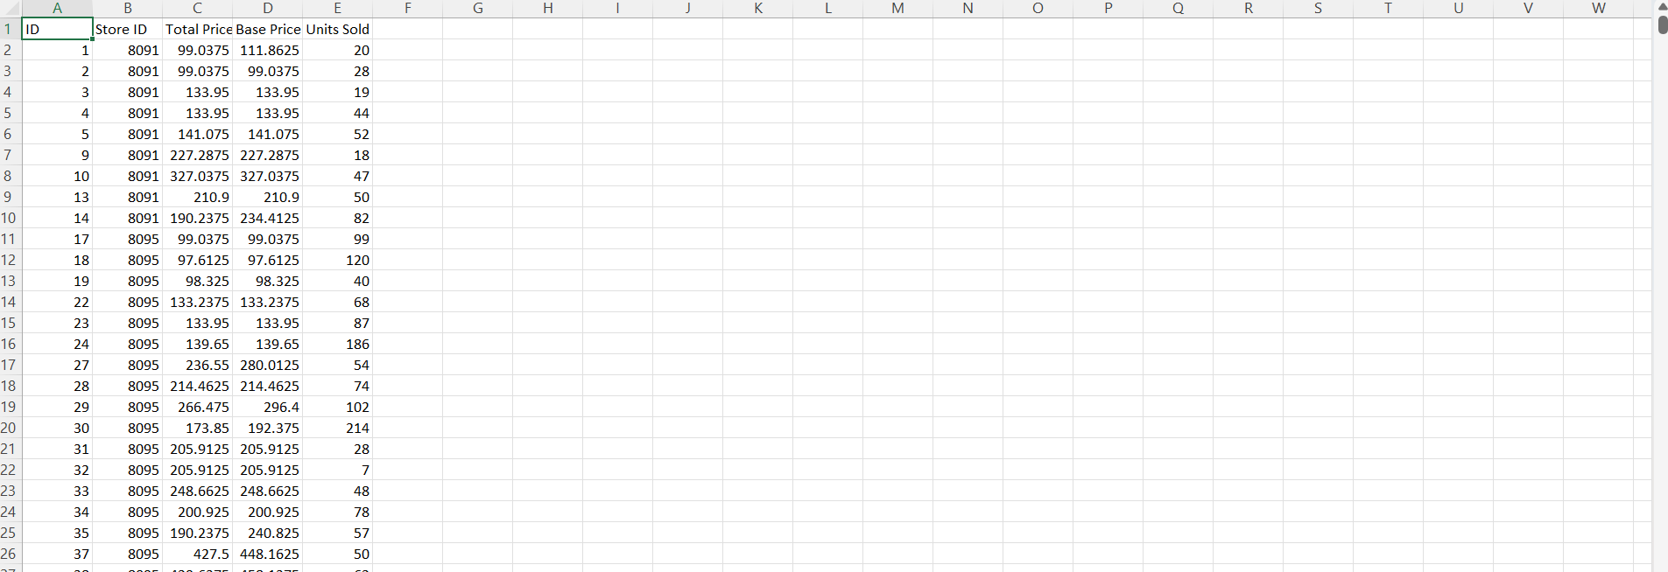

The dataset you have provided is a good starting point for predicting product demand. It includes a variety of features that may influence demand, such as historical sales data, product price, marketing spend, and competitor activity.

In addition to the features in the dataset, you may also want to consider collecting data on the following:

* Seasonality: Product demand may vary depending on the season. For example, demand for ice cream is typically higher in the summer than in the winter.
* Economic conditions: Economic conditions, such as unemployment and inflation, can also impact product demand.
* Events: Events, such as holidays or product launches, can also lead to spikes in demand.

Once you have collected all of the relevant data, you will need to preprocess it to ensure that it is in a format that can be used by the forecasting model. This may involve cleaning the data, imputing missing values, and transforming the data into a consistent format.

**Time Series Forecasting Techniques**

I would recommend using a time series forecasting technique to capture temporal patterns in the demand data. ARIMA and Prophet are two popular time series forecasting models that are well-suited for this task.

ARIMA models are a type of statistical model that can be used to forecast future values of a time series based on its past values. Prophet is a relatively new forecasting model that is specifically designed for business time series data. It is easy to use and can be trained quickly on even large datasets.

**Python Code**

The following Python code shows how to use Prophet to forecast product demand:

Python

import pandas as pd

from fbprophet import Prophet

# Load the demand data

df = pd.read_csv('product_demand.csv')

# Create a Prophet model

model = Prophet()

# Fit the model to the data

model.fit(df)

# Make predictions

future = model.make_future_dataframe(periods=30)

forecast = model.predict(future)

# Plot the forecast

forecast.plot()

This code will produce a plot of the forecast demand for the next 30 days. You can use this information to make decisions about inventory levels and other supply chain activities.

**Conclusion:**

By following the steps outlined above, you can build a machine learning model to predict product demand accurately. This will help you to reduce inventory costs and improve customer satisfaction.